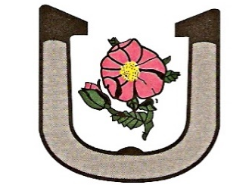

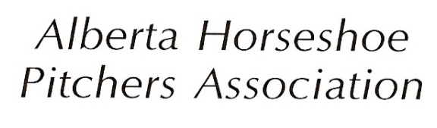

ENTRY FORM
2026 – PROVINCIAL CHAMPIONSHIPS
June 27 & 28, 2026, at the CALGARY HORSESHOE CLUB
(This is a TWO DAY Tournament, YOU MUST PLAY BOTH DAYS!)

ENTRY FEE: $55.00 – This covers entry fee and scorekeepers

PRE-REGISTER by June 24, 2026
Entry and FEES must be received by 9:00 PM
Make cheque payable to:
The Alberta Horseshoe Pitchers Association
(Postdated cheques MUST be dated no later than registration cut-off date)

- All players must be Members of the AHPA in good standing with dues paid for the current season.
- You must check in with the tournament office 30 minutes prior to your first scheduled game. Your horseshoes may be checked at this time.
- A proper shirt must be worn during play with your Name and Province professionally and visibly displayed on the back.
- All players must wear closed toed shoes.

Tournament Announcements 8:45am. Play begins at 9:00am sharp

SEND COMPLETED APPLICATION ALONG WITH ENTRY FEE TO:

Jane Cordingley, #303-7029-16 AVE. SE, CALGARY, AB T2E 6C5
Or email to jmcordingley@hotmail.com and etransfer funds
Please allow sufficient time for mailing, (NO PICTURES OF REGISTRATION FORM)

NAME: ______________________________________________________AHPA #: _______________

CELL PHONE: _______________________E-MAIL: _____________________________________________

DIVISION: 40'Men 30' Men (65 years and over)
Please circle one only: Women Junior Pee Wee

If you will require camping at the Calgary Horseshoe Club, we request pre-booking your site here. Limited sites are available with 30amp power.

Length of RV unit: ____________ Power Y / N Night arriving ___________ # Nights _______

Signature: _______________________________________________ Date: _____________________

